City View Gear Order Form

Please indicate below which items you would like to order and mark the quantity, sizes and total price in each field then total the entire order. All shirts are not pre-shrunk. Please turn in all order forms to City View front office and make checks payable to City View PTSA.

Orders due by Monday, November 16, 2015!

Student’s Name: _______________________________________________ Grade __________

ITEM # | ITEM NAME | COLOR | Cost | Quantity | Sizes | Total
G2000 | Adult Tee S-XL | Indigo Blue | $16.00
G2000 | Adult Tee 2X-4X | Indigo Blue | $18.00
G2000B | Youth Tee XS-XL | Indigo Blue | $12.00
G18500 | Adult Hoodie S-XL | Sport Grey | $24.00
G18500 | Adult Hoodie 2X-4X | Sport Grey | $27.00
G18500B | Youth Hoodie S-XL | Sport Grey | $22.00
G18600 | Adult Full Zip Hoodie S-XL | Sport Grey | $30.00
G18600 | Adult Full Zip Hoodie 2X-3X | Sport Grey | $33.00
J993B | Youth Full Zip Hoodie S-L | Ash Grey | $28.00
82800 | Adult Polo (Embroidered) S-XL | Sport Grey | $17.00
82800 | Adult Polo 2X-3X (Embroidered) | Sport Grey | $20.00
KP55Y | Youth Polo (Embroidered) S-L | Ash Grey | $17.00
Q800 | Tote Bag | Natural Cotton | $10.00
CSP08 | Knit Beanie (Embroidered) | Grey | $9.00
CAH35 | Lt. Grey hat (Embroidered) | Grey | $11.00
 | Window Sticker |  | $2.00
 |  |  |  | Order Total:

T-Shirt | 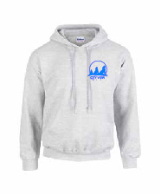  Hoodie | 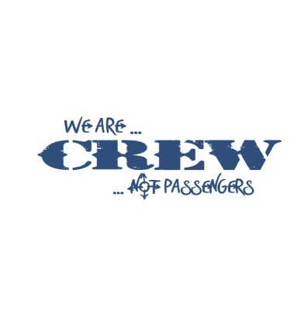  Back image for t-shirts and hoodies | Full Zip Hoodie

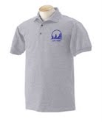  Adult Polo | 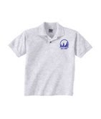  Child Polo | Natural Cotton  Tote Bag
Window Sticker  $2  (available in the front office) | Ball Cap | 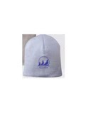  Knit Beanie

